Home Buildings

As at: April 2016

KEYFACTS ABOUT THIS HOME BUILDING POLICY

s at:

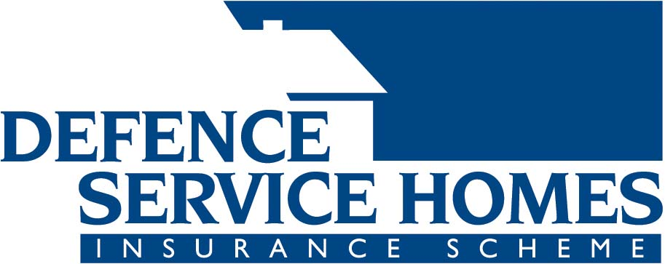

**THIS IS NOT AN INSURANCE CONTRACT**

STEP 1 Understanding the fact sheet

STE

This Key Facts Sheet sets out **some** of the main risks covered and not covered by this policy and other information you should consider. For all of the exclusions, conditions and limitations that apply in relation to the risks covered by this policy, you should read the **Product Disclosure Statement** (PDS) and all relevant policy documentation.

STEP 2 Check the type of cover and the risks covered

Under this **Home Buildings** policy any amounts you claim **include** GST.

|  |  |  |
| --- | --- | --- |
| **Risk** | **Covered?** | **Some examples of main conditions and exclusions (see PDS and other relevant policy documentation for details)\*** |
| Fire and Explosion | Yes | We do not insure you for loss or damage to the home that is caused by burning or heat, if that happens without flames. |
| Flood | Yes | Loss or damage caused to the home by flood, or a tidal wave, or the action of the sea. |
| Storm | Yes | Loss or damage caused to the home by a storm (including cyclone), snow or hail.  By storm we mean a violent wind that may occur with thunder or heavy rain.  We do not insure you for loss or damage caused by wind, rain, snow or hail entering the home unless it enters because of structural damage to the home that is directly caused by the storm, snow or hail. |
| Accidental breakage | Yes | Loss or damage to the home that is accidental and directly caused by a sudden and unexpected event.  We do not insure for loss or damage to glass forming part of a glasshouse; to awnings or shade cloths; to swimming pool linings or covers; to electrical motors that form part of the home; caused by tree lopping or tree removal at the site; or caused by any intentional act. |
| Earthquake | Yes | An excess of $200 applies to each earthquake claim.  An earthquake event begins with the first earthquake and ends 48 hours after that. |
| Lightning | Yes | Loss or damage to the home caused by lightning or thunderbolt. |
| Theft and Burglary | Yes | We do not insure you for theft or attempted theft by someone who lives in the home or is at the site with your consent or the consent of the person who lives in the home. |
| Actions of the sea | Yes | Loss or damage caused to the home by flood, or a tidal wave, or the action of the sea.  By action of the sea we mean the rise or fall of the sea over a short period of time. |
| Malicious Damage | Yes | We do not insure you if the act that caused the loss or damage is by someone who lives in the home or is at the site with your consent or the consent of the person who lives in the home. |
| Impact | Yes | By impact we mean sudden and violent collision.  We do not insure you for loss or damage to the home caused by any animal kept at the home or site, any animal or bird biting, chewing, pecking or scratching; or insects or vermin.  We do not insure you for loss or damage to a television aerial or a radio aerial or its mast unless that damage is caused by an event we insure in this policy. |
| Escape of liquid | Yes | We do not insure you for loss or damage that is caused by liquid splashing or gradually escaping because of something other than a sudden burst, leak discharge or overflow.  We do not insure you for the costs of repairing or replacing the defective item, or a defective part of the item, that causes the loss or damage, or any leaking shower base or shower walls. |
| Removal of debris | Yes | If we agree to pay your claim, we will also pay the reasonable costs of removing debris from the site.  There is a limit on how much we will pay. |
| Temporary accommodation | Yes | If we agree to pay your claim, we will pay reasonable costs of temporary accommodation.  There is a limit on how much we will pay. |

**\* The examples provided may only be some of many conditions /exclusions contained in this policy. These examples are considered to be the main conditions /exclusions to which most consumers would generally consider to be the main conditions/exclusions.**

STEP 3 Other things to consider

Limits

This policy has restrictions that limit your cover for certain events and items. For example; in the event of Escape of Liquid, if we accept you claim, we will pay for the damage to the home caused by the escape of liquid, but we do not pay for the costs of repairing or replacing the defective item, or a defective part of the item, that causes the loss or damage.

To find out these limits you need to read the PDS and other relevant policy documentation.

Excesses

If you make a claim, the excess is the amount you may pay for each incident. A number of different excesses may apply in respect to this policy, for example, for damage that occurs as the result of an earthquake, you will need to pay a minimum excess of $200, or the excess shown on your policy schedule, if the excess on the policy schedule is a higher amount. For more detail, please read the PDS and other relevant policy documentation.

Legal liability

This policy covers your legal liability when you are found to be legally responsible for damage or personal injury to a third party or their property. It is limited to $20,000,000. You should read the PDS carefully to determine the extent of this cover.

Cooling off period

If you decide you don’t want this policy within 14 days of it being issued and you haven’t made a claim, you can cancel it and receive a refund.

Limits and Exclusions in this policy

**This policy contains a number of specific terms and conditions, exclusions and limitations that may limit or exclude cover. This policy also contains other general conditions and exclusions that limit or exclude cover. For more detail, please read the Product Disclosure Statement and other relevant policy documentation.**

STEP 4 Seek more information

Types of Insurance cover offered by insurers

There are many different types of insurance cover available including where:

• You set the maximum level of cover and your payout is limited to that amount (Sum insured).

• You set the maximum level of cover and the insurer may provide you with some agreed extra cover above that amount (Sum insured plus margin).

• The insurer will provide all the costs to rebuild your home when there is a total loss of your property as a result of a significant insurance event such as bushfire (Total replacement).

You should consider which type of cover is best for you.

Failure to adequately insure your home building for its replacement value may result in underinsurance.

If you want more information on this policy contact us on 1300 552 662 or dsh@dva.gov.au

For more information on choosing insurance and to better understand insurance visit the Australian Government website: www.moneysmart.gov.au